DocNo: 001.C.1:1

Requirement Analysis Document
Version 1.0

Group Member:
孔令坤
周震超
王瑞吉
Document Language:
English

Revision History
Date | Version | Description | Author
2016-12-23 | 1.0 | Finish the whole document | Whole team

Key Word
CNN
Functional
Non-functional

Abstract
This document is important for our Software Engineering project, since it will define most of the requirement for this system. We describe not only functional but non-functional requirement as well. And give a specific hardware and software environment, and other necessary information for our system.
Table of Contents
1 Introduction 4
1.1 Purpose 4
1.2 Definition 4
1.3 Reference 4
2 System Overview 4
3 Detailed System Requirements 4
3.1 Functional Requirements 4
3.1.1 Functional/Behavioral 4
3.1.2 Non-Functional 4
3.2 Integration Requirements 4
3.3 Architecture Requirements 5
3.3.1 Computing Platforms 5
3.3.2 Environment Requirements 5
3.4 User Interface Requirements 5
4 Requirements Analysis Models 5
4.1 Functionality (behavioral) 5
4.1.1 Use Cases 5
4.1.2 Functional Analysis Model 5
4.2 Architecture & Bill of Materials 6
4.3 User Interface 6
4.3.1 Login interface 6
4.3.2 After a user is login 7
4.3.3 Administrator operation interface 7
4.3.4 Project create and edit form 8
4.3.5 Bug report form 8
4.3.6 Bug edit form 9
5 Requirements Traceability 9

- Introduction

Purpose
This is a requirement specification document. In this document, we will define most of the system requirement, so that all the develop team member can have a clear picture of the whole system. We define not only the functional requirement, but the non-functional requirement as well. This is the main document of this define phase, in this phase, we also have glossary document, use case specification document and we offer a prototype.

Definition
CNN: Convolutional Neural Networks
Bom: bill of material
Functional: some requirement that need to be realized
Non-functional: some requirement that cannot be realized but is indispensable to our system

Reference
CS231n: Convolutional Neural Networks for Visual Recognition— Stanford Vision Lab
Convolutional Neural Networks Applied to House Numbers Digit Classification—Pierre Sermanet, Soumith Chintala and Yann LeCun
- System Overvie
Main features of CNN:
- Lp-looping
- Multi-stage features
- Detailed System Requirements

Functional Requirements

Functional/Behavioral
There are several functional requirements of our project:
1. captcha crawler
It can crawl enough captcha pictures from the Internet, as you know, our project requires a big dataset consisting of at least 5000 members.

2. captcha partitioner
After getting the dataset, we need to partition each digit or literal from the other respectively, in order to make it easier for our program to conduct the final recognition stage.

3. captcha recognizer
In this part, the main method is CNN network.

Non-Functional
The main non-function requirement is the UI design of our application. It is implemented in python.

Integration Requirements
Null.

Architecture Requirements

Computing Platforms
CPU: i7 2.3Ghz or better
Main memory:
Minimize: 512MB recommendation: 2GB
GPU：optional

Environment Requirements
Ubuntu 14.04 + caffe + Anaconda + python2.7 + matlab r2016b

User Interface Requirements
Details in Readme.
- Requirements Analysis Models

Functionality (behavioral)

Use Cases
This system is divided into eight use cases: Image Input, Image Estimate, Parameter Input, Parameter Estimate, Image Adjust, Image Output, Image Browse, Error.
Each use case is specified in the use case specification document. Please refer to each use case specification document to get detail information to know more about each use case.

Functional Analysis Model
We use Rational Rose to create the use case model. Here is the view of use case model.
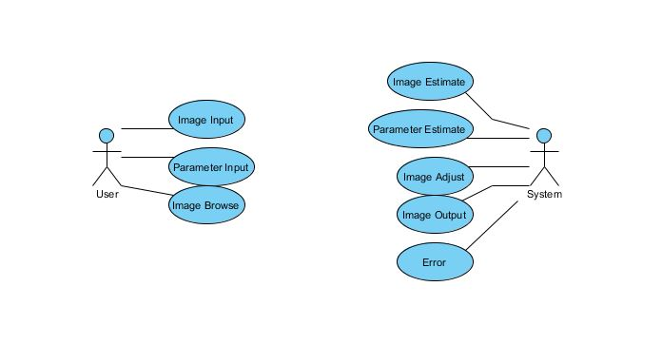

Architecture & Bill of Materials

Seq | Item | Qty | Functional Description | Vendor/ Manufacturer | Product  Name | Version | Part  No. | Purchase  Reuse  Upgrade | Standard  (Y/N) | CR  #* | Remark
1 | System | High | Provide database service, response all the request from the clients | ASUS,  China | Laptop | 1.0 | 10001 | R | N | 2
2 | Operation System | High | Platform to develop system | Microsoft, America | Windows 7 | 7 Professional | 10002 | U | N | 3
3 | UML tools | Middle | Use to design system | IBM Rational, America | Rational Rose | 2003 | 10003 | R | Y | 2
4 | Develop Environment | Middle | Integrated develop environment to develop system. | MathWorks, America | Matlab | 9.0 | 10004 | R | Y | 4
5 | Office Tools | Middle | To edit documents, table, etc. | Kingsoft,  China | WPS | 2013 Edition | 10005 | R | Y | 1
* If not a standard, indicates Standards Change Request #

User Interface
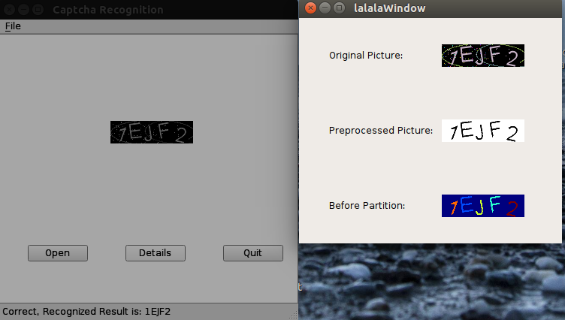

- Requirements Traceability
In phase of BTM developing, we will make three modules: Use-case Module, Analysis Module, and Design Module, so there exists the traceability among those modules.
In UML, we describe this in the following ways:
